//Struct & Function

TASK-1:

#include <stdio.h>

#include <string.h>

struct foods

{

float price1, price2, price3, item1, item2, item3, member,total_cost, result;

};

float individual_payment()

{

struct foods payment;

printf("Quantity Of Paratha: ");

scanf("%f",&payment.item1);

printf("Unit Price: ");

scanf("%f",&payment.price1);

printf("Quantity Of Vegetable: ");

scanf("%f",&payment.item2);

printf("Unit Price: ");

scanf("%f",&payment.price2);

printf("Quantity Of Mineral Water: ");

scanf("%f",&payment.item3);

printf("Unit Price: ");

scanf("%f",&payment.price3);

printf("Number of People: ");

scanf("%f",&payment.member);

payment.result = (payment.item1*payment.price1 + payment.item2*payment.price2 + payment.item3*payment.price3)/payment.member;

return payment.result;

}

int main()

{

float x = individual_payment();

printf("Individual people will pay: %.2f tk\n",x);

}

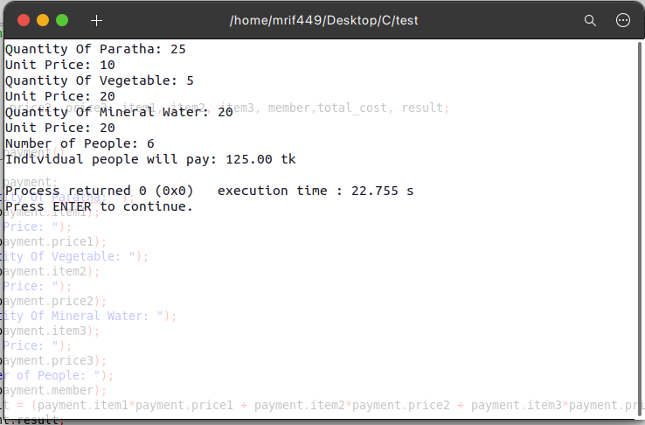

TASK-2:

#include <stdio.h>

#include <string.h>

struct perfect_number

{

int x, start, end;

};

int number_checking()

{

struct perfect_number numbers;

scanf("%d",&numbers.start);

scanf("%d",&numbers.end);

for(numbers.x=numbers.start; numbers.x<=numbers.end; numbers.x++)

{

int value=numbers.x;

int i, sum = 0 ;

for(i = 1 ; i < value ; i++)

{

if(value % i == 0)

sum = sum + i ;

}

if (sum == value)

printf("%d\n\n", value);

}

}

int main()

{

number_checking();

}

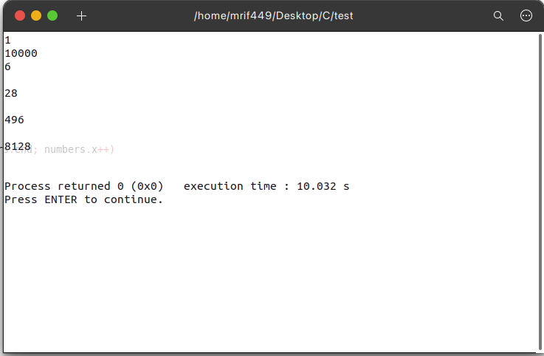

//System Call

TASK-1:

#include<stdio.h>

#include<string.h>

#include<stdlib.h>

#include<fcntl.h>

#include<sys/stat.h>

#include<unistd.h>

/* Sample Input:

./File /media/rahadul/D/C Diary

C

is

hard

-1

*/

int main(int argc,const char **argv)

{

int iFd = 0;

char *Directory = NULL;

char *Filename = NULL;

char *Filepath = NULL;

struct stat sfileInfo;

if(argc != 3)

{

return -1;

}

Directory = (char *)malloc(260);

Filename = (char *)malloc(260);

Filepath = (char *)malloc(260);

Directory = strcpy(Directory,argv[1]);

Filename = strcpy(Filename,argv[2]);

sprintf(Filepath,"%s/%s",Directory,Filename);

int result = access (Filepath, F_OK);

if(result!=0)

{

iFd = creat(Filepath,0644);

FILE *File;

char s[1000];

File=fopen(Filepath,"w");

while(1)

{

scanf("%s",s);

if(strcmp(s,"-1")==0) break;

fprintf(File,"%s\n",s);

}

fclose(File);

}

else

{

FILE *File;

char s[1000];

File=fopen(Filepath,"w");

while(1)

{

scanf("%s",s);

if(strcmp(s,"-1")==0) break;

fprintf(File,"%s\n",s);

}

fclose(File);

}

close(iFd);

free(Directory);

free(Filename);

free(Filepath);

return(0);

}

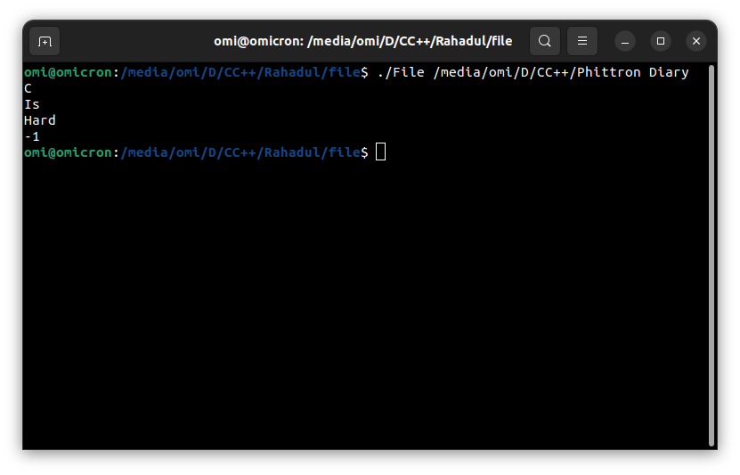

TASK-2:

#include <stdio.h>

#include<unistd.h>

int main()

{

pid_t child=fork();

if(child==0)

{

printf("I am child\n");

}

else

{

pid_t grandchild=fork();

if(grandchild==0)

{

printf("I am parent\n");

}

else

{

printf("I am grandchild\n");

}

}

return 0;

}

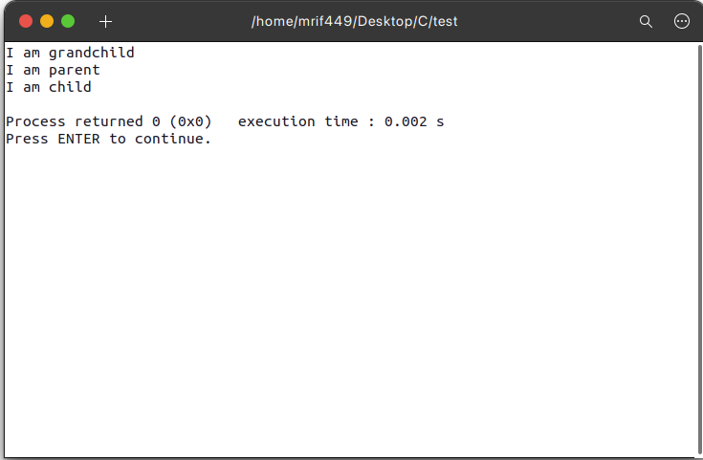

TASK-3:

#include <stdio.h>

#include<sys/types.h>

#include<unistd.h>

int main()

{

int a = fork();

int b = fork();

int c = fork();

int counter = 0;

if(getpid()%2!=0)

{

fork();

counter++;

}

printf("%d\n",counter);

}

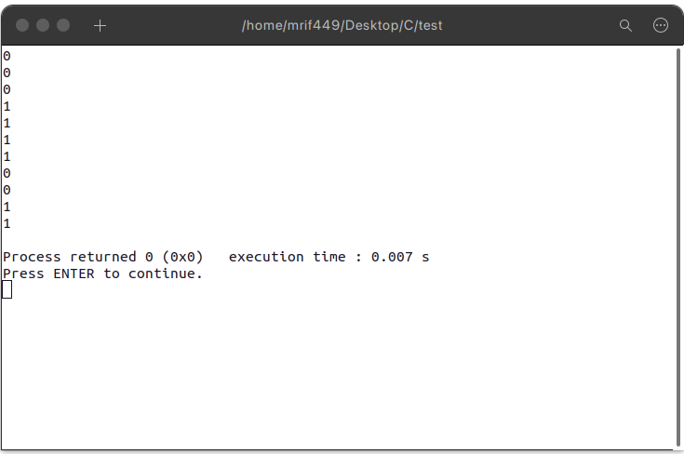

TASK-4:

int main()

{

// array length assumed as 5

int temp_var, x, y;

int len_array = 5;

int array[len_array];

for(int x=0; x<len_array; x++)

{

scanf("%d",&array[x]);

}

temp_var = 0;

len_array = sizeof(array)/sizeof(array[0]);

for (x = 0; x<len_array; x++)

{

for (y=x+1; y<len_array;y++)

{

if (array[x]<array[y])

{

temp_var=array[x];

array[x]=array[y];

array[y]=temp_var;

}

}

}

for (x=0; x<len_array; x++)

{

printf("%d ",array[x]);

}

}

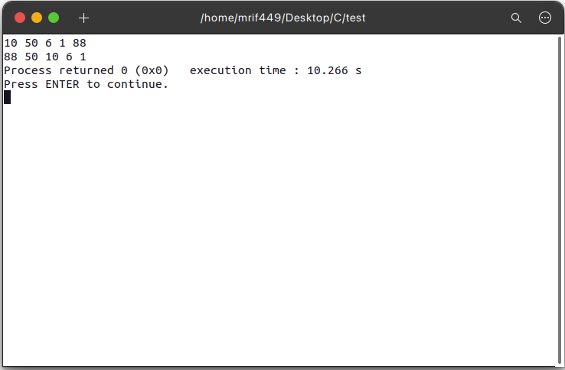

#include <stdio.h>

#include <string.h>

int main()

{

// array length assumed as 5

int temp_var, x, y;

int len_array = 5;

int array[len_array];

for(int x=0; x<len_array; x++)

{

scanf("%d",&array[x]);

}

temp_var = 0;

len_array = sizeof(array)/sizeof(array[0]);

for (x = 0; x<len_array; x++)

{

if(array[x]%2 != 0)

{

printf("%d is ODD\n",array[x]);

}

else

{

printf("%d is EVEN\n",array[x]);

}

}

}

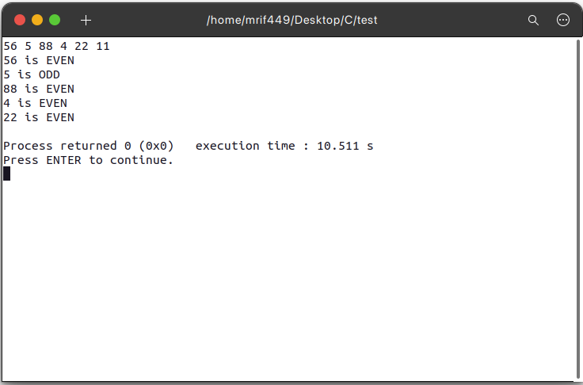

TASK-5:

#include<stdio.h>

#include<stdlib.h>

#include<unistd.h>

#include<sys/types.h>

#include <stdio.h>

#include <unistd.h>

int main()

{

int pid, cpid, gpid;

int count = 0;

pid = fork();

if(pid == 0)

{

cpid = getpid();

pid = fork();

if(pid==0)

{

printf("1. Parent process ID: %d\n2. Child process ID: %d \n3. Grandchild process ID: %d\n4. Grandchild process ID: %d\n5. Grandchild process ID: %d\n", getpid(),cpid,getppid(),getppid(),getppid());

}

}

return 0;

}

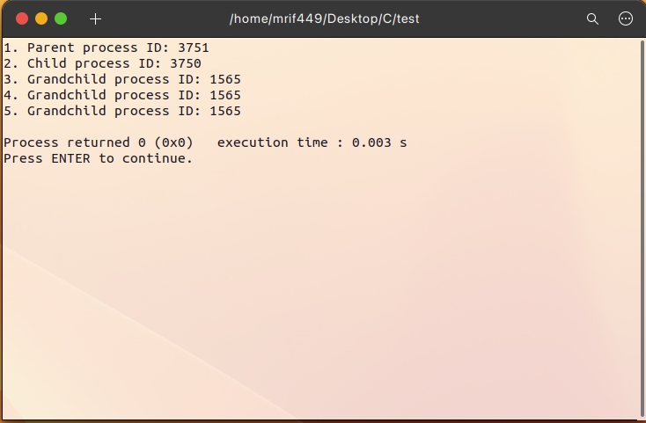

//Threading

TASK-1:

#include <stdlib.h>

#include <unistd.h>

#include <pthread.h>

int thread_counter = 1;

int thread_number=1;

int sleep_time = 1;

int runner = 5;

void *threadFunction(void *vargp )

{

sleep(sleep_time);

printf("thread-%d running" , thread_number);

}

int main()

{

for(int x=0; x < runner ; x++)

{

pthread_t thread_id;

pthread_create(&thread_id, NULL, threadFunction, NULL);

pthread_join(thread_id, NULL);

printf("\nthread-%d closed\n" , thread_number);

thread_number++ ;

}

return 0;

}

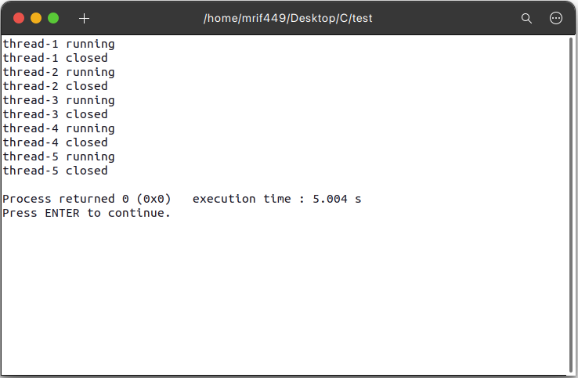

TASK-2:

#include <stdio.h>

#include <stdlib.h>

#include <unistd.h>

#include <pthread.h>

int counter=1;

void *printer(void *argv)

{

int *thread_number=(int*)argv;

for(int i=0;i<5;++i)

{

printf("\nthread_number %d prints %d\n",*thread_number,counter);

counter++;

}

}

int main()

{

pthread_t t_id1,t_id2,t_id3,t_id4,t_id5;

int t_num1=1,t_num2=2,t_num3=3,t_num4=4,t_num5=5;

pthread_create(&t_id1,NULL, printer,(void*)&t_num1);

pthread_create(&t_id2,NULL, printer,(void*)&t_num2);

pthread_create(&t_id3,NULL, printer,(void*)&t_num3);

pthread_create(&t_id4,NULL, printer,(void*)&t_num4);

pthread_create(&t_id5,NULL, printer,(void*)&t_num5);

pthread_join(t_id1,NULL);

pthread_join(t_id2,NULL);

pthread_join(t_id3,NULL);

pthread_join(t_id4,NULL);

pthread_join(t_id5,NULL);

}

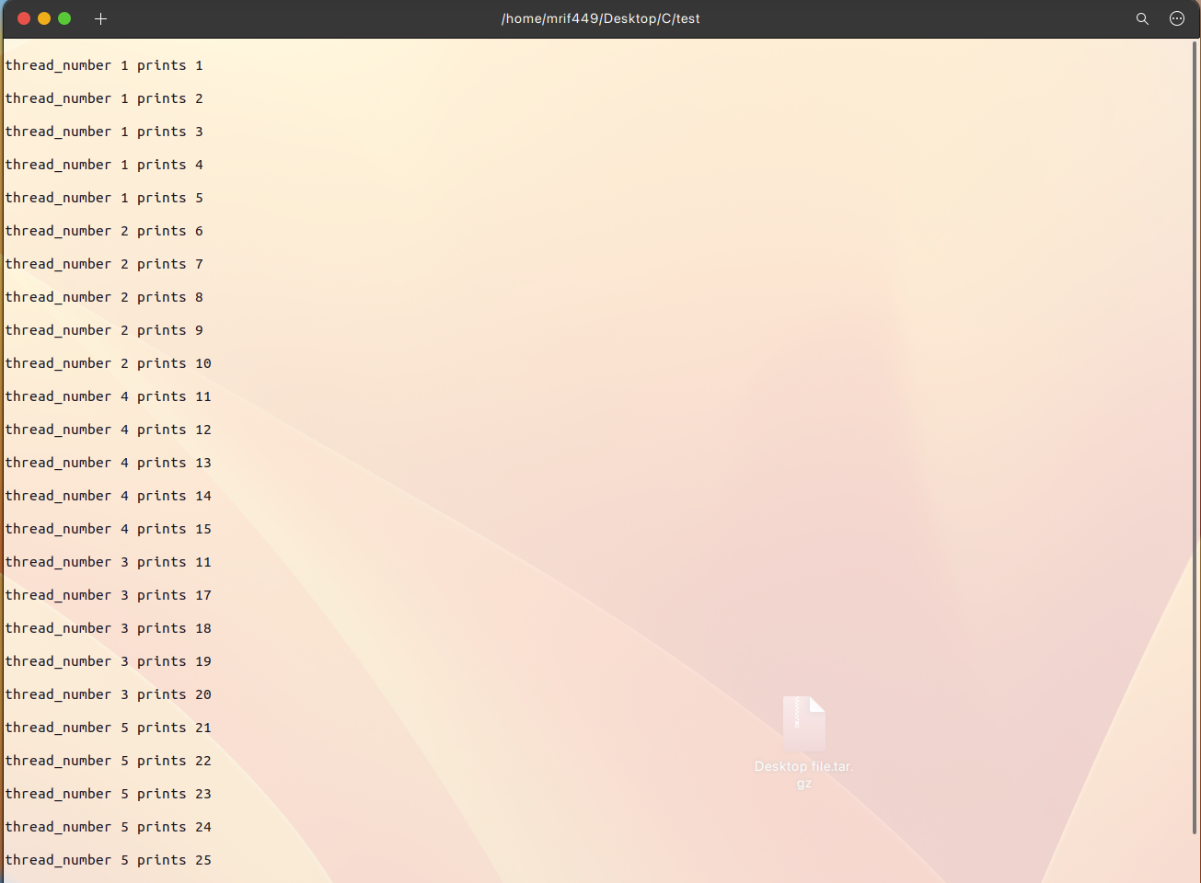

TASK-3:

#include <stdlib.h>

#include <stdio.h>

#include <pthread.h>

#include <string.h>

void *ASCII_counter(void *input1)

{

char *data = (char *)input1;

int output = 0;

int *final = malloc(sizeof(int));

int x = 0;

while (data[x] != '\0')

{

output += data[x];

x++;

}

*final = output;

return (void *)final;

}

int main(void)

{

char *user_name1="Rohim";

char *user_name2="Korim";

char *user_name3="Sumon";

pthread_t value1, value2, value3;

pthread_create(&value1, NULL, ASCII_counter, user_name1);

int *number1;

pthread_join(value1, (void **)&number1);

pthread_create(&value2, NULL, ASCII_counter, user_name2);

int *number2;

pthread_join(value2, (void **)&number2);

pthread_create(&value3, NULL, ASCII_counter, user_name3);

int *number3;

pthread_join(value3, (void **)&number3);

if (*number1 == *number2 && *number1 == *number3)

{

printf("Youreka\n");

}

else if (*number1 == *number2 || *number1 == *number3 || *number2 == *number3)

{

printf("Miracle\n");

}

else

{

printf("Hasta la vista\n");

}

printf("%d\n", ASCII_counter(user_name1));

return 0;

}

